**SMARTWATCH**

**Embedded system:-**

An Embedded system is a minicomputer that uses a microprocessor to do computation. Generally, embedded systems are used for a specific purpose or general-purpose. General-purpose embedded systems do more things but are large in size and cost, that’s why we design a specific type of embedded system for a specific purpose, which takes less time and less space to complete the task.

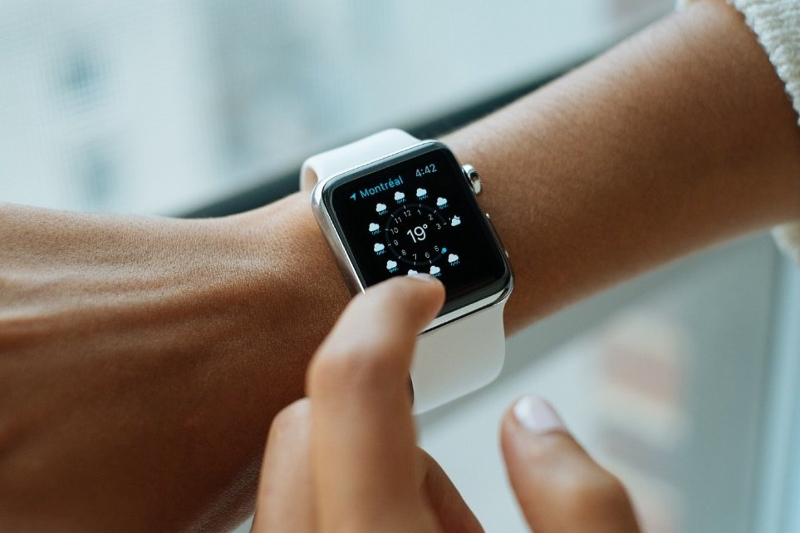

One of the interesting and ultimate examples of an embedded system is Smartwatch. Smart consists of

1. Navigation
2. Personal assistant
3. Health monitoring
4. Smart home controlling remote
5. Fall detection etc.

Based on the pulse rating in the wrist it calculates a person's health and updates regularly about a health issue. Due to advancements in artificial intelligence these watches now predict health issues with very good accuracy. Using some other sensors like an accelerometer, this embedded system is capable of fall detection. Based on abrupt changes in body movement which indicates an accident, these systems alert emergency contacts. It’ll make decisions based on some threshold. If it crossed the threshold then it’ll decide as the accident happened.

**Sensors:**

Altimeter

Heart rate sensor

Bio impedance (respiratory rate)

Compass

GPS

Sp02 moniter to measure blood oxygen levels

**Microcontroller** :-

The Fit One uses an ARM Cortex M3 Core (32MHz,256KB flash) made by ST

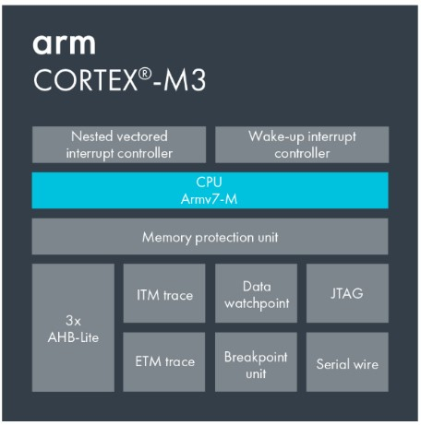

Apple S1 ( 32-bit ARMv7 based application processor APL0778)

One of the buzzing applications nowadays is the smart home, to control things we need a remote or mobile which is unusual to carry every time in the pocket. But watches are always on our wrist, due to their user interface with touch display access we can control all the things in the smart home. This can be used for setting alarms, listening to music, phone calls, etc. Due to internet connectivity in embedded systems, it can do the high computational task with cloud computing. It’ll show the status of that day's temperature and weather report etc.

We have to appreciate it size of the watch. These watches are almost the same as the size of an analog watch but it makes a lot of different applications. It’s indicating how embedded systems are grown too small in size, large in capability and cheap in price compared to advantages with this.